14th February 2017

**YOKOHAMA IBERIA TO JOIN MOTORTEC AUTOMECHANIKA MADRID**

YOKOHAMA Iberia will attend Spain’s leading International Automotive show known as MOTORTEC Automechanika Madrid which will be held from the 15th-18th March 2017.

The show attracts manufacturers of components, distributors, workshop associations, media and other businesses offering a platform that combines the interests of suppliers and service providers within the industry in both Spain and Portugal.

At the last show, over 600 professional exhibitors attended from over 21 countries including the Iberian Peninsula, Latin America and North Africa. The expectations for this year are equally very high and in addition to the networking opportunities and promotional activity there will be a programme of seminars and workshops on matters of interest to the industry.

For the first time, YOKOHAMA Iberia will participate in the event with a wide range of innovative products which showcase the Japanese premium tyre manufacturer’s latest advances in tyre technology and offering customers the pleasure of driving in comfort.

Additionally the new visual image for 2017 with the Premiership football team Chelsea FC will be displayed. YOKOHAMA is the Official Shirt Partner of Chelsea FC.

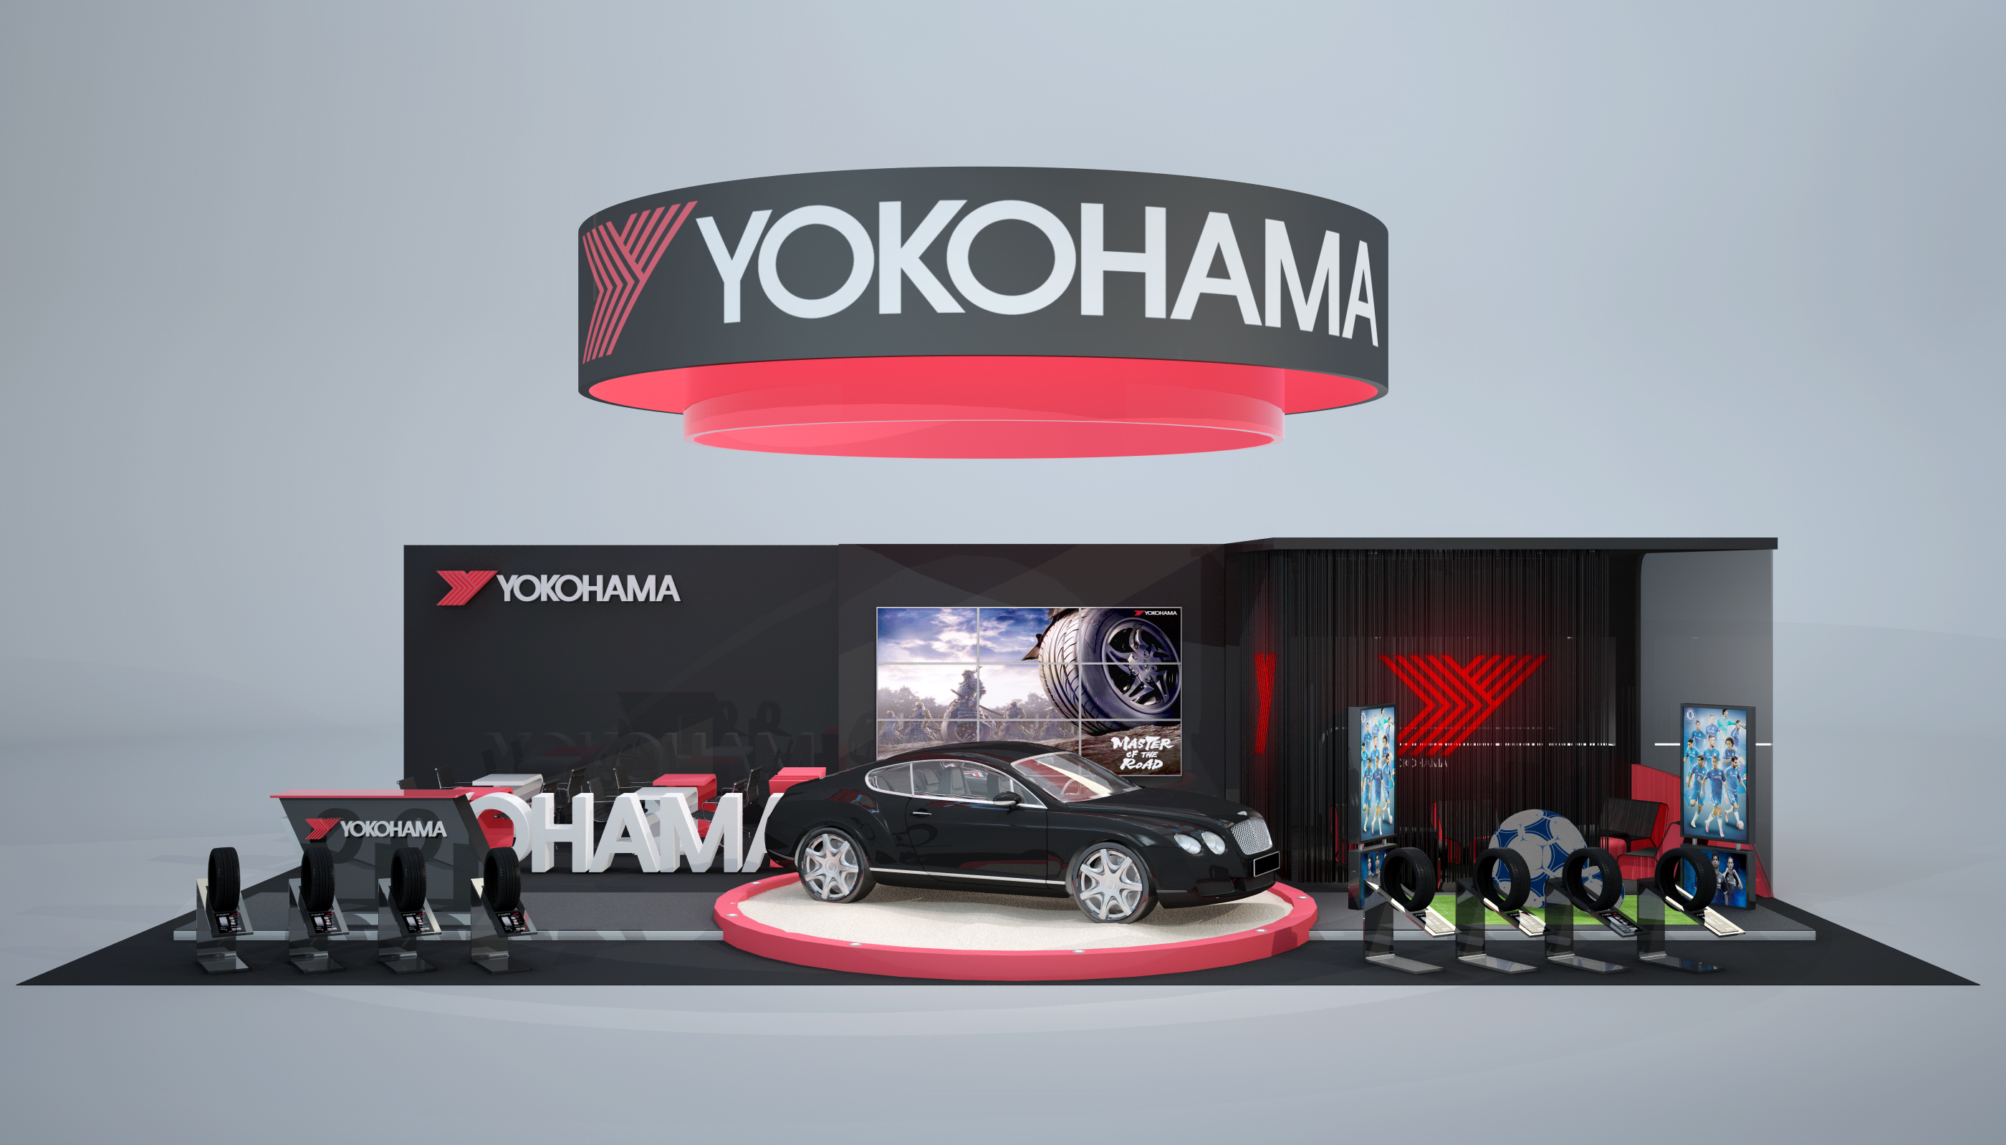

*Yokohama Iberia Booth at Motortec Automechanika Madrid*